Certificate of Attendance

29th ANNUAL ANTI-FRAUD CONFERENCE
April 11-13, 2018
Monterey, California

Wednesday, April 11, 2018
General Session 8:00-11:45 a.m.
Opening Hour - General Session (Coalition Against Insurance Fraud) [MCLE, SIU]
D. Jay
(1 hour)

General Session (Arson & Fraud Reporting and Immunity Issues)
[MCLE, SIU]
D. Wood
(1 hour)
General Session (Deep Dark Web)
[MCLE, SIU]
J. Stephenson
(1.5 hours)
(Select 1) Afternoon Workshops (2 hours) 1:00-3:00 p.m. |  |  | (Select 1) Afternoon Workshops (2 hours) 3:15-5:15 p.m.
 | Medical Fraud for Field Investigators  [MCLE, SIU, POST, AB/ADJ]  J. Farrell |  |  | Onboard Vehicle Infotainment Forensics  [MCLE, SIU, POST, AB/ADJ]  J. Bonsal, E. Fatzinger
 | Surveillance Management – Maximizing the results and Outcomes  [MCLE, SIU, POST, AB/ADJ]  S. King, J. Bobrowsky |  |  | Vocational Rehabilitation in Wokers’ Compensation – Where the Fraud Lies  [MCLE, SIU, POST, AB/ADJ]  E. Danowitz
 | Auto Insurance – Vehicle Theft Fraud 101  [MCLE, SIU, POST, AB/ADJ]  B. Schnabel, M. Simone |  |  | Restitution Loss and Taking: The Mudding Road to Recovery  [MCLE, SIU, POST, AB/ADJ]  J. Snyder
 | Compound Pharmaceuticals: Billing Misrepresentations  [MCLE, SIU, POST, AB/ADJ]  T. Hurtado, R. Milton, C. Lock |  |  | Effective Use of a Forensic Accountant in Insurance Litigation  [MCLE, SIU, POST, AB/ADJ]  S. Kamiabipour, S. Weitzman
 | Social Media Investigations  [MCLE, SIU, POST, AB/ADJ]  B. Farnsworth |  |  | Suspect Water Damage Claim Investigations including Vendor Schemes  [MCLE, SIU, POST, AB/ADJ]  D. Koehler
Thursday, April 12, 2018

(Select 1) Morning Workshops (2 hours) 8:00-10:00 a.m. |  |  | (Select 1) Morning Workshops (2 hours) 10:15-12:15 p.m.
 | Workers’ Compensation – How the System is Supposed to Work and How Fraud  [MCLE, SIU, POST, AB/ADJ]  W. Zachry |  |  | Defending Against Inflated Medical Bills  [MCLE, SIU, POST, AB/ADJ]  S. Sandhu
 | Tenacious-Applying sound fundamentals and proven strategies to the investigation of staged auto collisions  [MCLE, SIU, POST, AB/ADJ]  C. Pusser, C. Sullivan |  |  | Evaluating Documents for Potential Fraud: Trust But Verify  [MCLE, SIU, POST, AB/ADJ]  K. Hansen, R. Harer
 | Cellular Data Analysis  [MCLE, SIU, POST, AB/ADJ]  B. McGirk |  |  | The Tactical Approach to Medical Fraud  [MCLE, SIU, POST, AB/ADJ]  M. Trimbe
 | Legal Ethics  [*MCLE Ethics, SIU, POST, AB/ADJ]  C. DeSilva, M. Sokolove |  |  | Strategies and Approaches in the Trial of Complex Criminal and Civil Insurance Fraud Actions Against Medical Providers  [MCLE, SIU, POST, AB/ADJ]  K. Zimmerman, T. Fraysse
 | Developing an Investigative and Legal Outline for Provider  [MCLE, SIU, POST, AB/ADJ]  G. Oard, T. Barton |  |  | Premium Fraud: Deceit, Greed and Money: “Two D.A.s Tell All – From Detection to Investigation to Successful Prosecution  [MCLE, SIU, POST, AB/ADJ]  J. Nerone, N. Pantaleo
General Session 1:30-2:30 p.m
General Session (Utilizing Analytics to ID Major Fraud) [MCLE, SIU]
M. Kim
(1 hour)
(Select 1) Afternoon Workshops (2 hours) 3:00-5:00 p.m.
Auto Body Shop Repair Fraud and Organized Crime Rings
[MCLE, SIU, POST, AB/ADJ]
P. Cerney, R. Kelly
From Everest to Arsonist – Suicide in the Courtroom [MCLE, SIU, POST, AB/ADJ]
U. Castellon, D. Wood
Lessons Learned From Fighting the Tide of California’s Capping Schemes
[MCLE, SIU, POST, AB/ADJ]
J. Friedl, N. Hasan
Catastrophic Disasters – Fighting Fraud from the Beginning
[MCLE, SIU, POST, AB/ADJ]
M. McKee
Understanding Personal Lines Auto Fraud with Emphasis on Non-Standard Policies
[MCLE, SIU, POST, AB/ADJ]
B. Randall, J. Bobrowsky, R. Voller
Friday, April 14, 2017
General Session 8:00-9:30 a.m.
Behind the San Bruno Gas Explosion – The Investigation Into PG&E
[MCLE, SIU]
B. Strottman, J. VanDerbeken
(1.5 hours)
Morning Workshop (2 hours) 9:45-11:45 a.m
From Detection to Conviction: Key Issues and Ethics Hypotheticals
[*MCLE Ethics, SIU, POST]
D. Banda, E. von Geldern, T. Evans

To receive Continuing Education Credit for this training maintain completed form in your files.

This conference is approved by CDI as providing continuing education to SIU Personnel, Agents and Brokers, Independent Adjusters, and Claims Staff.

A maximum of 10 hours are available for Agents/Brokers and Adjusters.

All courses contain components related to SIU and integral anti-fraud personnel CE requirements.

The CDAA has approved 18 hours of MCLE credit by the State Bar of California, including 2 hours of Ethics.
*MCLE Ethics credits available for these courses.

There are two-hour courses are POST certified for peace officers. A maximum of 12 hours are available for POST credit.

By signing below, I certify that I have attended the presentations listed above
and am entitled to the following number of Continuing Education Credits.
Total Hours ________
Name: (please print) Title
Company: E-Mail:
Address:
City, State, Zip Work #:
Signature: Date:
Certificate of Attendance

This is to certify that

«FIRST» «LAST»

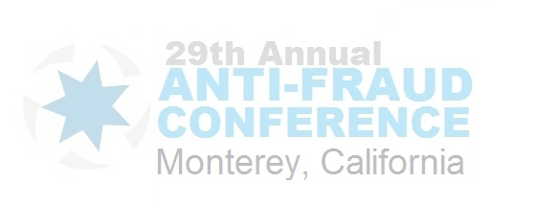
attended the
29th Annual Anti-Fraud Conference

Presented by the AFA, CDAA, CDI, & NICB
April 11 - 13, 2018
Monterey, California

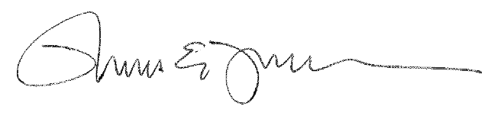

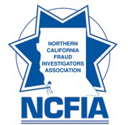
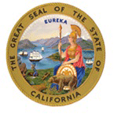
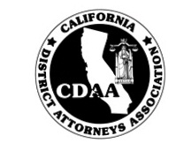
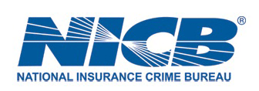
Thomas Fraysse, President


